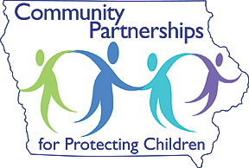
200 S Howard Street
Indianola, Iowa 50125
www.cppconline1.com
Hello!
Welcome to the Community Partnerships for Protecting Children (CPPC) Steering Committee! We are so happy to have you.
Please let this binder serve as an orientation to our Steering Committee, the purpose of the Steering Committee and the structure of CPPC and Decategorization (DCAT) in Madison, Marion and Warren Counties. Below is a breakdown of the contents of this binder.
- Behind this page you will find a list of meeting dates. Dates, times and locations are listed for the provider group in each of our three counties as well as Steering Committee meeting.
- Steering Committee roles and responsibilities are listed on page 3. These are the roles and responsibilities of the 12 voting members (4 representing each county).
- Pages 4-6 contain information on the structure of CPPC and DCAT both locally and at the state level.
- CPPC is broken down into four strategies which guide everything that CPPC does. Information on the four strategies and the levels within them, can be found on pages 7-11.
- Lastly is our application to be considered for one of our open voting member positions. If you are interested in serving as a voting member, complete the application and return it to me. The Steering Committee will then review your application.
You are welcome to attend the CPPC Steering Committee meetings as often as you are able. We would love to continue to network with you and learn about your agency and what it has to offer!
Please contact me with any questions you have. I look forward to working with you!
Sincerely,
Sarah Gibson
CPPC Coordinator
515.468.8181
shohanshelt@gmail.com

