.
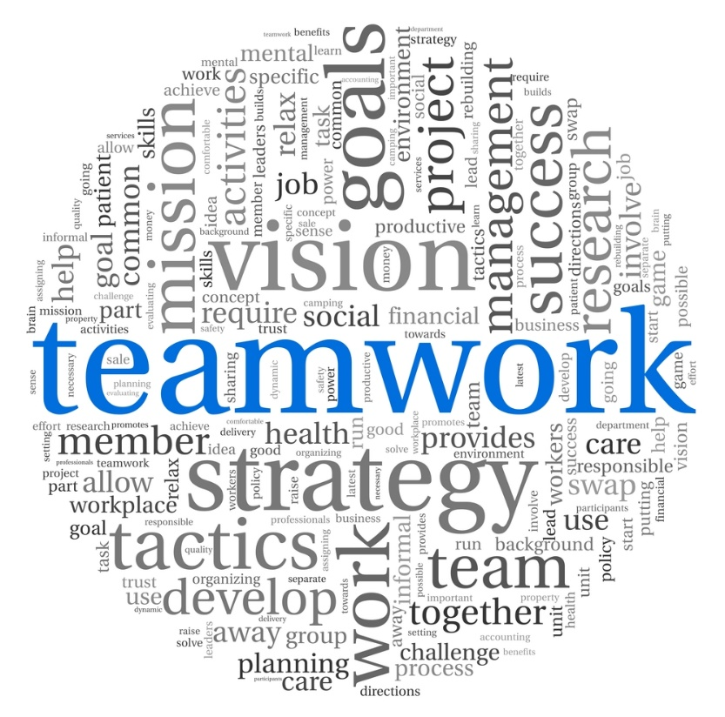 |  | CPPC Newsletter  - Madison, Marion & Warren  - June 2017

Protecting children is everyone’s business

What’s New with CPPC
by Sarah Hohanshelt, CPPC Coordinator
School’s out for summer! Hopefully the warmer weather and sunshine have given you a boost during these summer months. Fiscal year 2017 (FY17) was, like the last 6 fiscal years that I’ve been in this position, a busy one! Please let this newsletter serve as an update on all things Community Partnerships for Protecting Children (CPPC) as well as a look into what’s to come FY18 beginning July 1st!

Al’s Pals
What a fun year for Al’s Pals! This is one of my favorite parts of my job. The children enjoy Al, Ty and Keisha so much and get a lot out of the lessons. The amount of participation still blows me away.
This year I completed 15 classroom visits at the 10 schools/centers that participated in Al’s Pals. We had two schools discontinue use of the Al’s Pals curriculum due to changes in their district’s requirements for guidance time. One center did not return my calls or emails and one will return to Al’s Pals next year as there was a medical emergency this year. We expect to have 11 schools/ centers utilizing Al’s Pals in FY18. I will visit 16 classrooms over the course of the year!
Due to budget constraints, we do not have an Al’s Pals contract, so we are unable to provide CDs for home use or trainings as we have in years past. I have been helping schools order CDs and register for trainings at their own expense.

CPPC Website
For those of you that are not familiar with our website, www.cppconline1.com, please take a moment to look around! The website currently averages between 1,500 and 2,000 views per week, though we had one week of over 4,000 hits this year! Our goal is to provide the communities in Madison, Marion and Warren Counties with a “one stop shop” to find local resources, job postings, trainings, events, etc. Additionally, I am sending out weekly updates which outline new material posted on the website as well as remind subscribers of upcoming events for the week. If you’d like to be on that mailing list, please visit the website and click Contact then fill out the online form and hit submit! If you have an upcoming event, training or a job posting, please feel free to email it to me.
I will be on maternity leave from the end of July through September. We will have an individual checking my email, updating the website and sending out updates on the same schedule I keep.

CPPC Steering Committee
Our Steering Committee meets monthly on the first Tuesday of each month at 200 S Howard Street in Indianola. Our next meeting is Tuesday, October 3rd. We will be taking July-September off as I will be on maternity leave.
We currently have vacancies for voting members in Warren and Marion Counties. We are also seeking representation from the faith community, youth, foster/adoptive parents and parents formerly involved with DHS to attend our meetings and provide valuable input. If you are interested in learning more about becoming a voting member or more about CPPC/DCAT please contact me at shohanshelt@gmail.com.
If you would like to be added to the mailing list to be sent meeting minutes and reminders, please email me at shohanshelt@gmail.com. Below are the upcoming meeting dates:
October 3, November 7 and December 5

Community Based Family Team Meetings

What’s New?
The FY17 DCAT Plan as well as the FY16 Annual Progress Report are available for your review on the CPPC website. The FY18 DCAT Plan is due October first while the FY17 Annual Progress Report is due December 1st. Both will be posted on the CPPC website for your review.
The progress reports details what DCAT and CPPC accomplished in the given fiscal year. All contracts, mini grants, etc. are summarized into a 20+ page document. The DCAT annual plan is a 10-page summary of what we plan to do this year. Please take a moment to review these reports. Remember, this is your state and federal tax money at work!
Looking forward into the FY18, Joe will continue monitoring all contracts and ensure all programming is running smoothly. In August, we will hold our year-end DCAT Governance Board meeting where Joe will give a summary on FY17. All year-end reports shared with the board will be posted on the CPPC website.
Should you have any questions regarding DCAT, please contact Joe Burke at JBurke@dhs.state.ia.us.

DCAT Update
by Joe Burke, DCAT Coordinator
We are continuing to work hard to get referrals in our counties. I am continuing to talk about and promote CBFTMs at each provider meeting. The majority of our referrals come from schools, but can be made by anyone as these are not DHS involved cases. If you would like to make a referral for a CBFTM please visit www.cppconline1.com and fill out the referral & release of information forms which can be found under the Our Programs > Community Based Family Team Meetings tabs.
In FY17, I completed five prep meetings, five initial meetings and three follow up meetings for a total of 11 meetings. We will continue to promote CBFTMs as we continue into FY18!
What is DCAT?
Decategorization (DCAT) was designed to be a process that combines the individual state appropriations for child welfare services into a single fund to encourage the development of services that better meet the needs of youth and families by allowing the local county flexibility in how these funds are used. Participation by the Department of Human Services, Juvenile Court Services and the County are required terms of the legislation.
DCAT is an effort to significantly change the child welfare system to one that is needs based, family focused, easily accessible, more intensive, less restrictive and cost effective.

Summer Fun
by Sarah Hohanshelt, CPPC Coordinator

Summer Bucket List
Summer seems to pass so quickly. It’s hard to get everything in you hope to in just a few short months of nice weather. One way to focus on what you really hope to do as a family this summer is to create a summer bucket list. Essentially, it’s a list of “must dos” for the summer. It’s a fun way to involve your kids in planning summer activities while preventing you from becoming overwhelmed by all the things there are to do!
Some ideas for your summer bucket list may include:
- Going on a nature scavenger hunt
- Having a water balloon fight
- Taking in some fireworks
- Learning a new skill
- Doing something nice for a neighbor, family member or friend
- Making a bird feeder
- Making s’mores
- Having a lemonade stand
- Visiting the zoo
There are plenty of free and low cost activities in our area during the summer months!
A free summer bucket list template can be found at: http://www.yellowblissroad.com/free-printable-summer-bucket-list/

Summer Safety
Water Safety
According to the CDC, “Drownings are the leading cause of injury death for young children ages 1 to 4, and three children die every day as a result of drowning.” With many families spending time around the water as the weather gets hotter, follow these four steps to be prepared for your time spent in the water:
- A responsible adult should always be supervising young children.
- Enroll your children in formal swimming lessons so they can learn to swim.
- Take a CPR certification course.
- Always wear a life jacket at the lake.
Heat and Sun Exposure
Let’s face it, Iowa summers can be miserable. The heat and humidity sometimes seem unbearable. It seems that we all know someone, have been someone or have heard about someone on the news that has suffered from heat-related illness. But did you know, children ages four and under are at the greatest risk for heat-related illness?
When trying to prevent heat-related illness in children, the same rules you use as an adult apply:
- Dress in loose, lightweight and light colored clothing.
- Schedule your outdoor activities when the temperature is coolest (morning or evening).
- Drink plenty of water.
- Never leave children in a parked car.
A couple of significant sunburns increases your child’s risk of skin cancer as adults. Be sure to apply sunscreen regularly to your child’s skin every time you go outside. It is recommended that you use sunscreen with at least an SPF of 15. Also, be sure to dress your child in clothing that covers their skin when appropriate to prevent burning.
Prevent Injury
More than 200,000 children are treated for injuries they incur on the playground every year. Again, with the nicer weather, may families are choosing to spend their free time at the park. While the park is a great way to burn off energy and spend time outdoors, they also have potential to post a safety risk to children. Here are a few things you can do to help prevent playground-related injuries:

For More Information

https://www.cdc.gov/family/kids/summer/

https://www.oxfordlearning.com/summer-learning-loss-statistics/
- Make sure the playground is well maintained.
- Check the surfaces under the playground equipment. Is it safe, soft and well maintained?
- Know the signs and symptoms of concussions.
- Closely supervise young children.

Learning Outside of School
If you are a parent or someone who cares about children, allow me to scare you with some statistics about learning retention over the summer months…
- Over two and a half months of math skills are lost over the summer.
- Two months of reading skills are lost.
- It can take up to two months from the start of the school year to get student brain development back on track.

Marion County
The Marion County Provider’s group meets the first Monday of each month at 9:30 a.m. at Marion County Public Health (2003 N Lincoln, Knoxville).
The goal of this group is to bring together local community partners, school staff, mental health providers, etc. to share information regarding events, concerns, needs, etc. within the communities in Marion county. Each month, an agency is also selected to give a presentation which details the services they provide within the
The summer dates for this meeting are:
June 5th
July 3rd
August 7th
For more information, contact Teresa Higginbotham at thiggin@marionph.org.
For information on Marion County events visit www.cppconline1.com.

Warren County
The Warren County Provider’s group meets the 2nd Tuesday of each month at 9 a.m. at Indianola Schools Administration Office Board Room. This group meets to distribute information among school staff, community partners, mental health providers, etc. Anyone is welcome to attend!
The fall meeting dates are as follows:
This group does not meet in June, July or August.
September 12th
October 10th
November 14th
For more information, contact Kyla Bandstra at kyla.bandstra@indianola.k 12.ia.us.
For information on Warren County events visit www.cppconline1.com.

Madison County
A community collaboration group, Madison County Cares, meets the fourth Tuesday of each month at Sports Page in Winterset at noon.
The summer meeting dates are as follows: June 27th
July 25th
August 22nd
Anyone is welcome to attend!
Madison County Cares provides the communities within the county with several events including: the Health, Wellness and Safety Fair, Distracted Driving Prevention Curriculum and Family Fun Day. For more information on these events, come to a meeting or email Sarah at shohanshelt@gmail.com.
For information on Madison County events, visit www.cppconline1.com.

County News
by Sarah Hohanshelt, CPPC Coordinator
But there is hope! As little as 2 to 3 hours a week is all that is needed to prevent learning loss during the summer months. Spend time learning with your child in ways that don’t typically happen during the school year to help keep their interest in learning during the summer months. Take a trip to the library or read a book outside. Physical activity has also been linked to better concentration and improved math scores. Go on walks or nature hikes, enroll your child in park and recreation activities or go for a swim to keep physically active this summer! Small changes to your summer routine can make for a smooth transition back to formal learning in the fall.

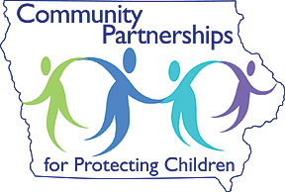
Community Partnerships for Protecting Children
200 S Howard Street
Indianola, Iowa 50125
www.cppconline1.com

